Statistical Orbit Determination: Homework 8

1. **Monte Carlo**

An orbit was simulated using J2, Drag, and mu dynamics on a LEO spacecraft. 1000 Monte Carlo cases with slight perturbations in the initial condition were simulated. Corner plots of the statistics of the distribution at hour 0,6,12,18,24 are provided for analysis. The statistics for the distributions are notated on the plots in the figures below.

Time 0 plots:

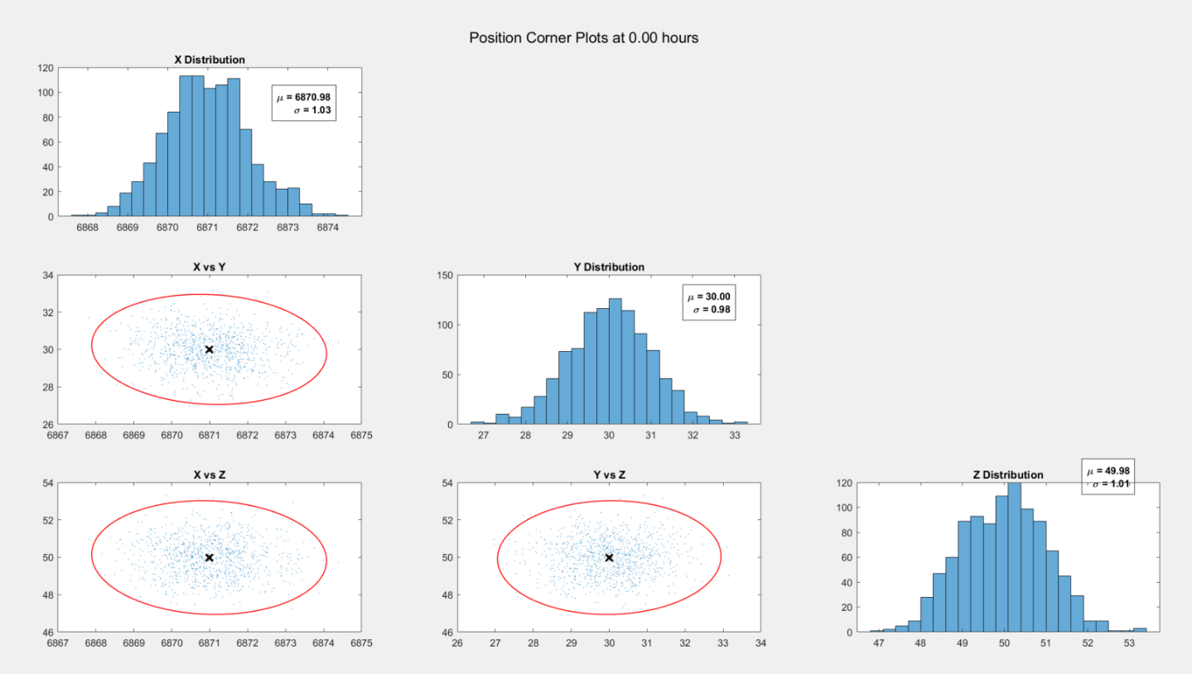

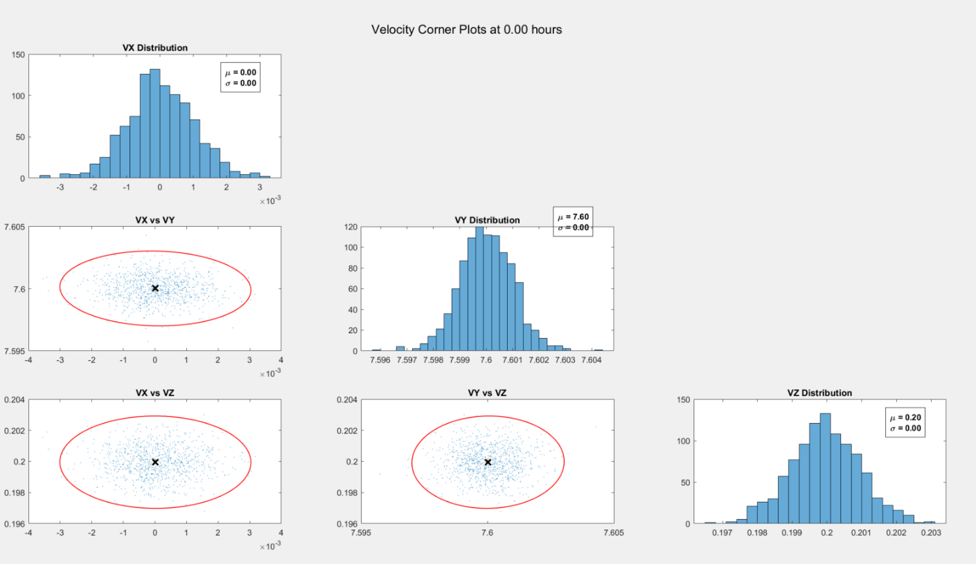

Everything at the initial time is nice and Gaussian as expected with the nominal trajectory and mean of the distribution right on top of each other.

Time 6-hour plots:

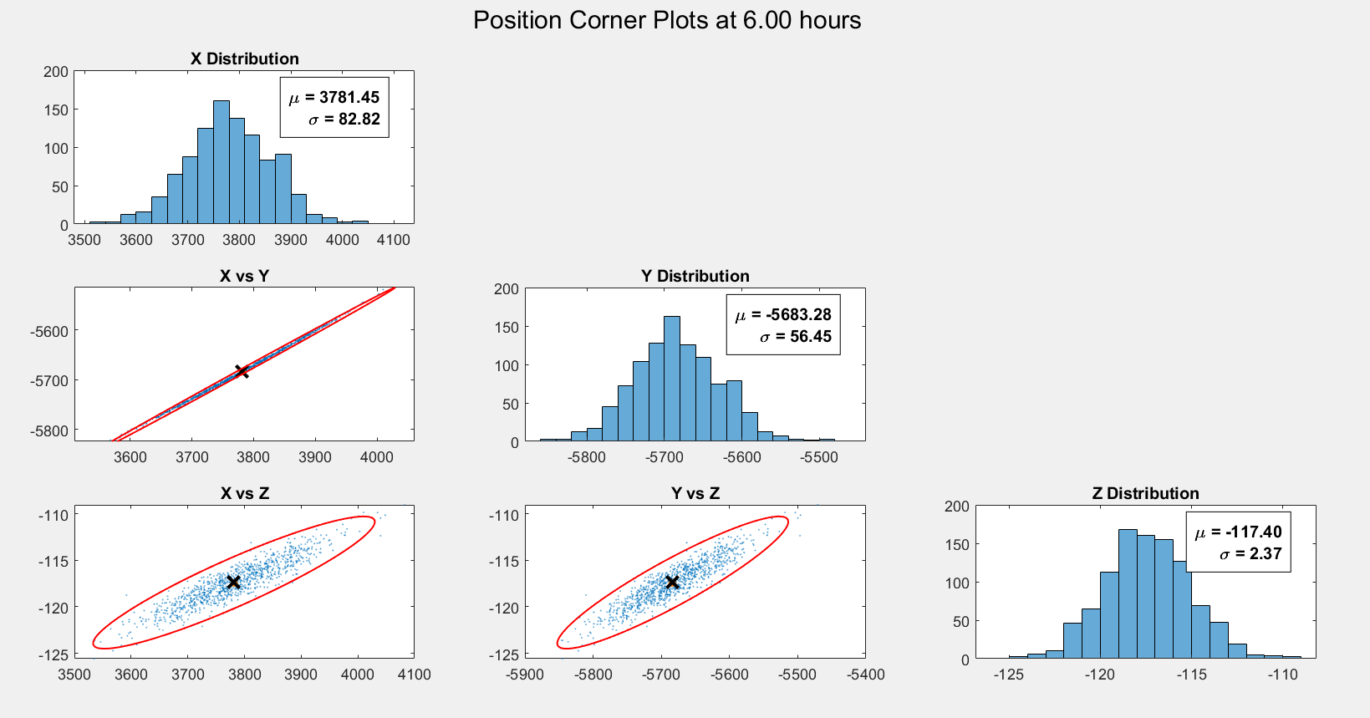

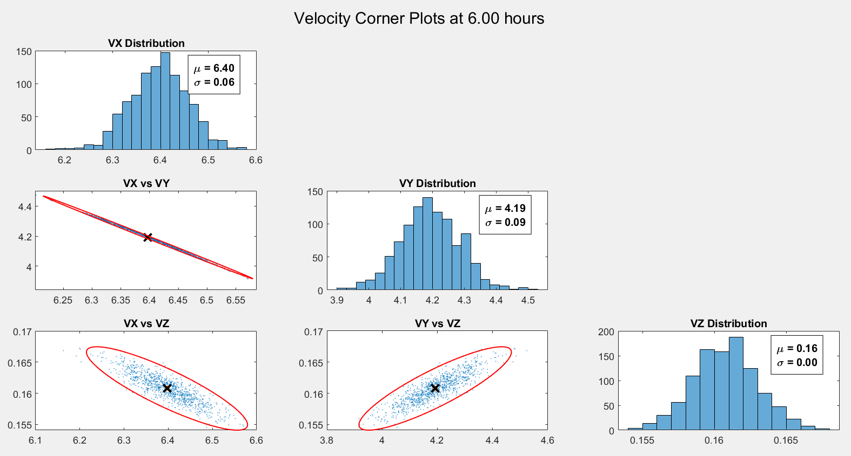

Clearly after 6 hours, correlations between the variables become very clear. The mean of the distribution and nominal trajectory are still on top of each other.

Time 12-hour plots

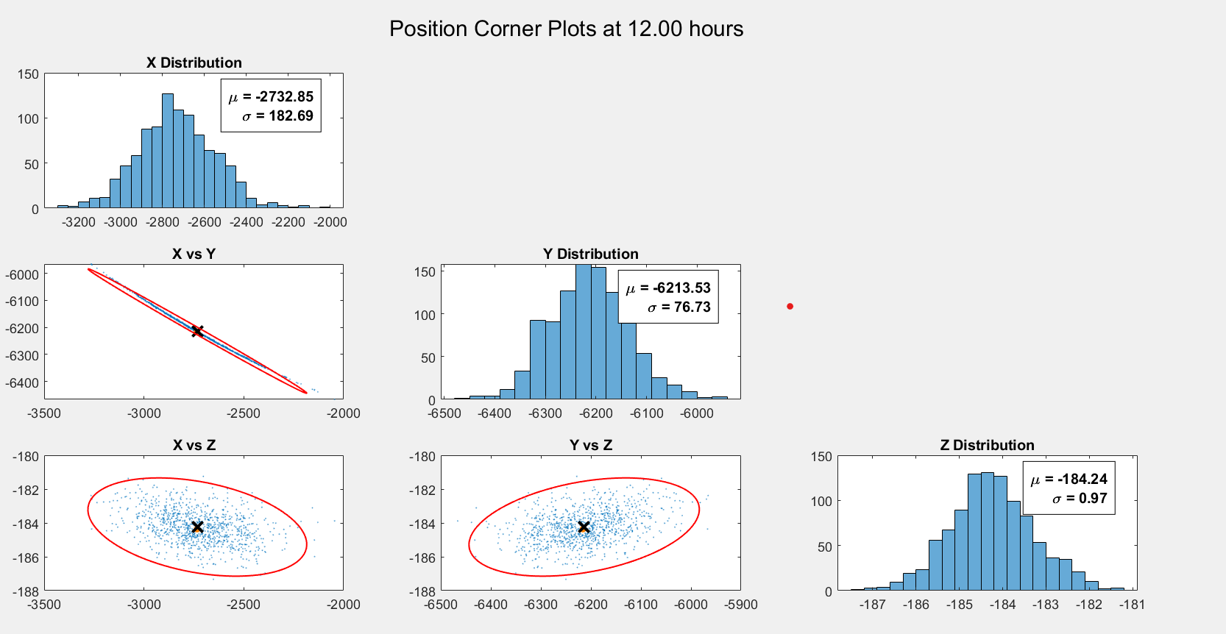

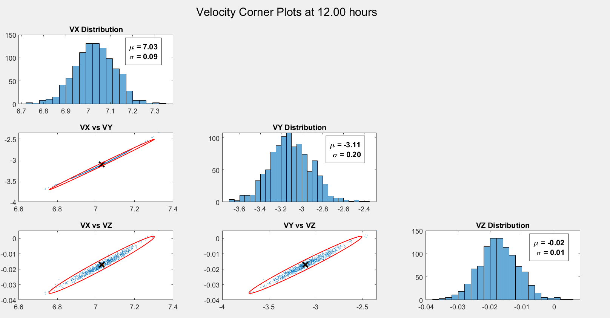

After 12 hours, more of the distribution is beginning to look more like the banana shape at the edges of the distribution (especially in the X direction)

Time 18-hour plots

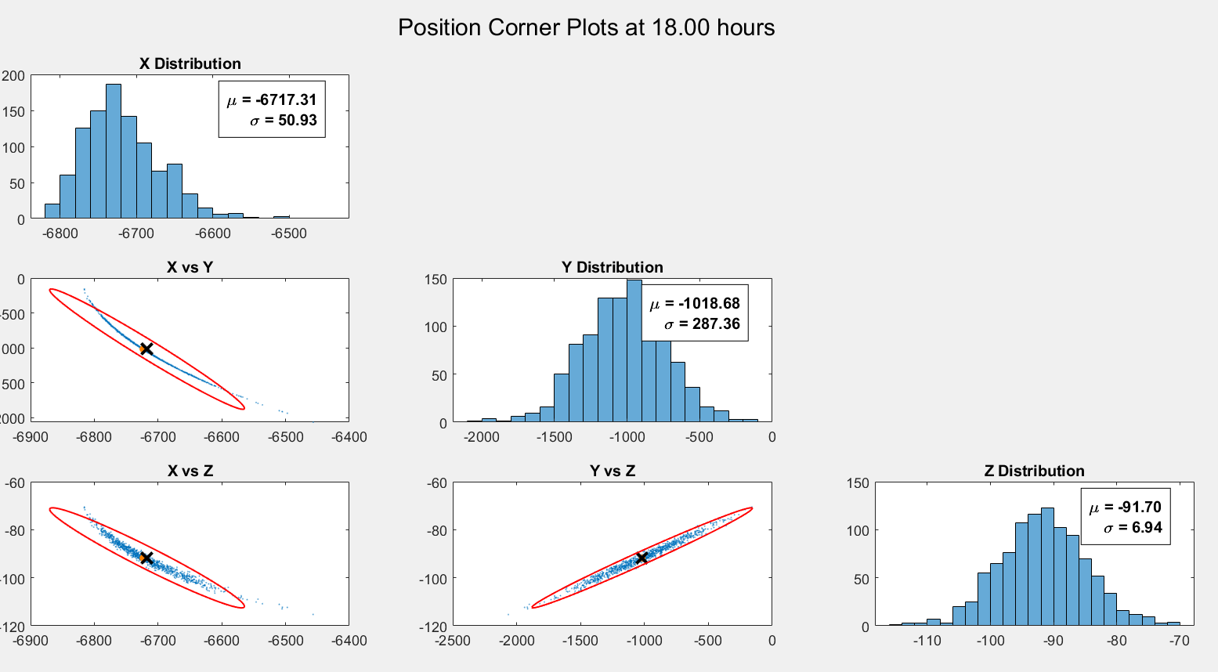

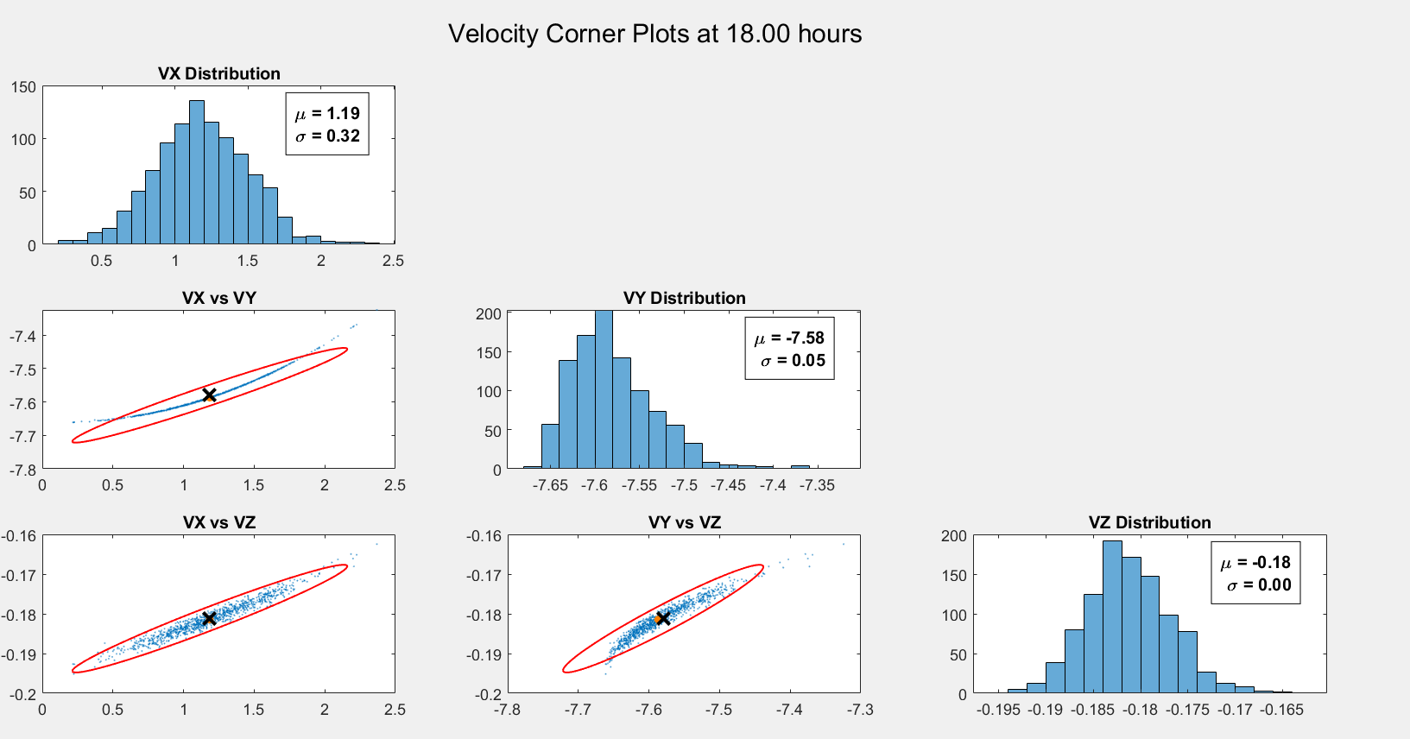

After 18 hours, it can be seen that the orange dot (nominal trajectory) and the “X” (distribution mean) are now becoming more distinguishable from one another as the distribution becomes increasingly less gaussian due to the nonlinear propagation effects.

Time 24-hour plots

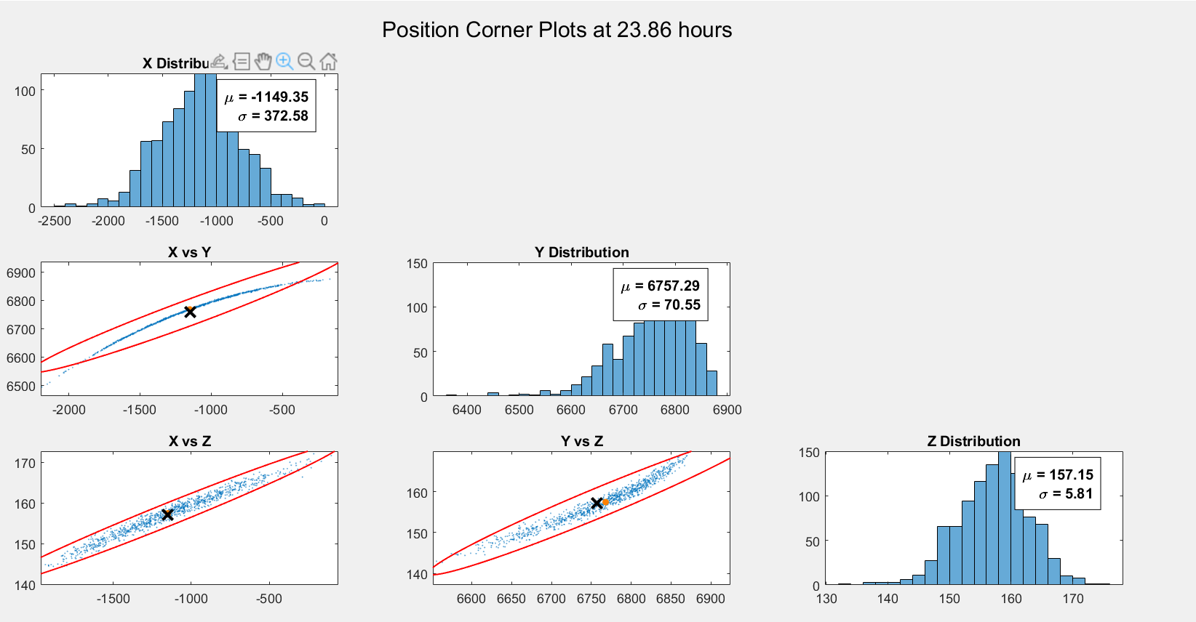

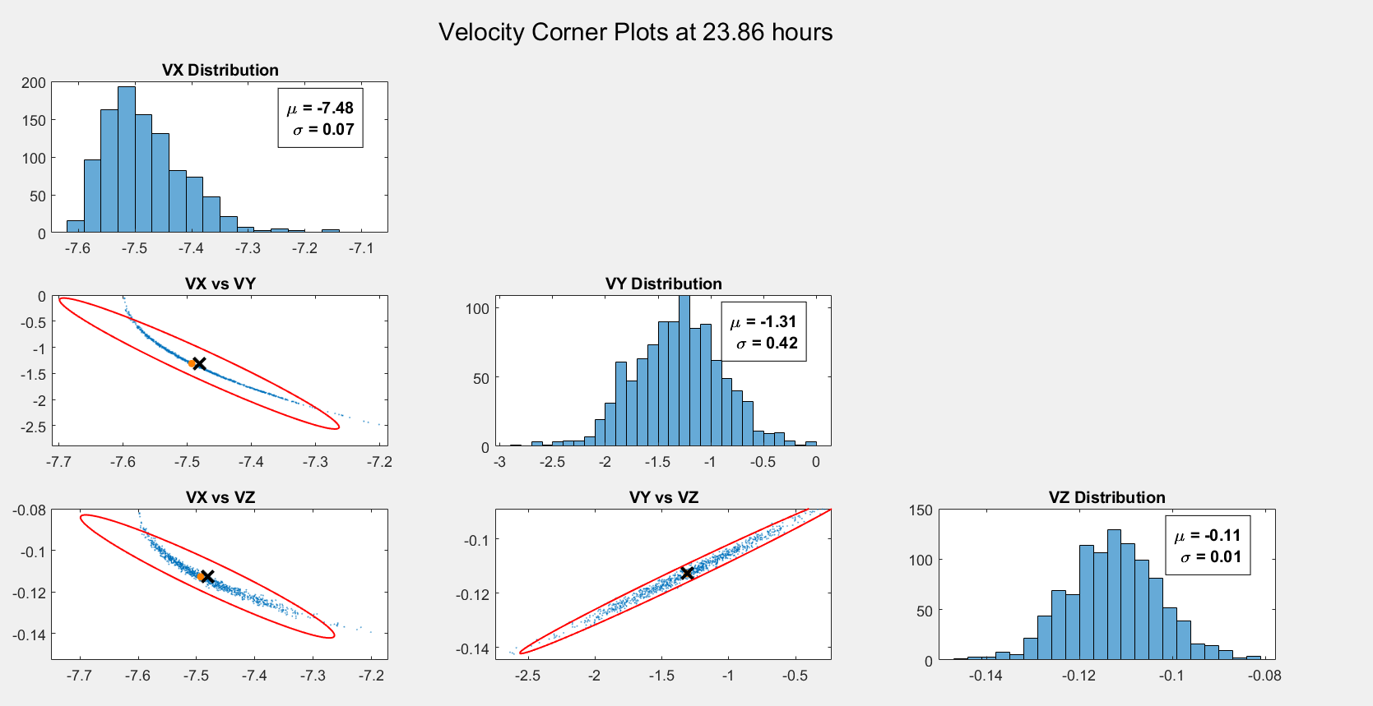

By the end of the propagation, the orange dot and X are very distinct in multiple of the plots with a very distinct banana shape of the monte distribution. This shows of the mean of the nonlinearly propagated distribution will no longer equal the nominal trajectory like it once did at the initial conditions.

1. **Linear Covariance**

Now the covariance is linearly propagated using the State Transition Matrix in a similar manner to that is done with the Linearized Kalman filter (Phi*P*PhiT). The same plots with this overlaid are now shown for the same time intervals.

Time 0-hour plots

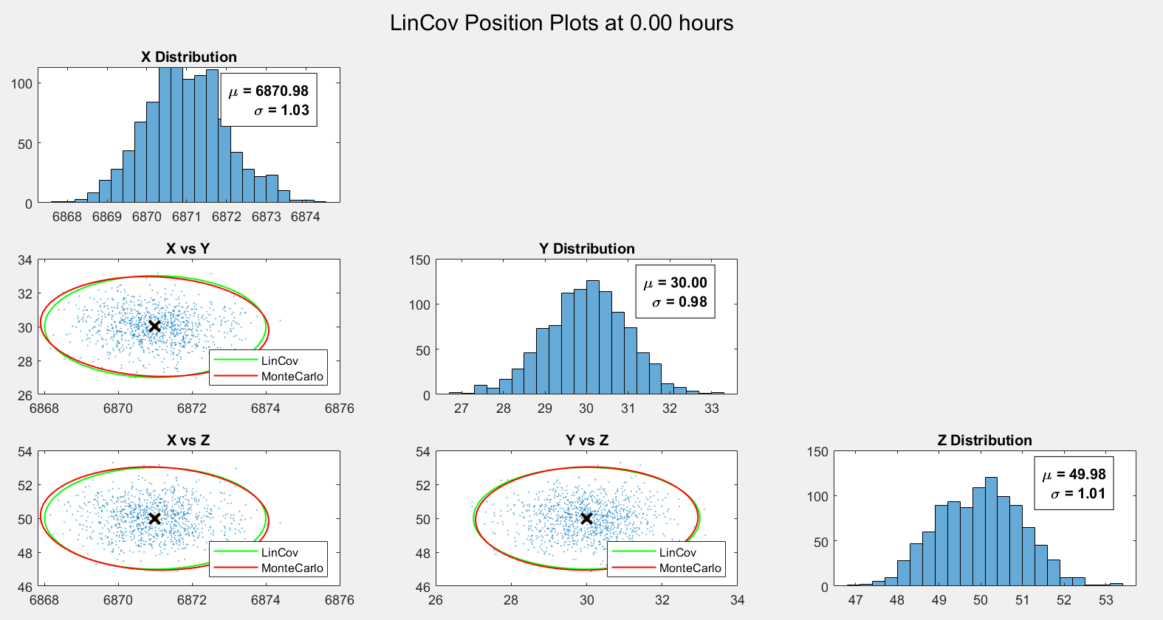

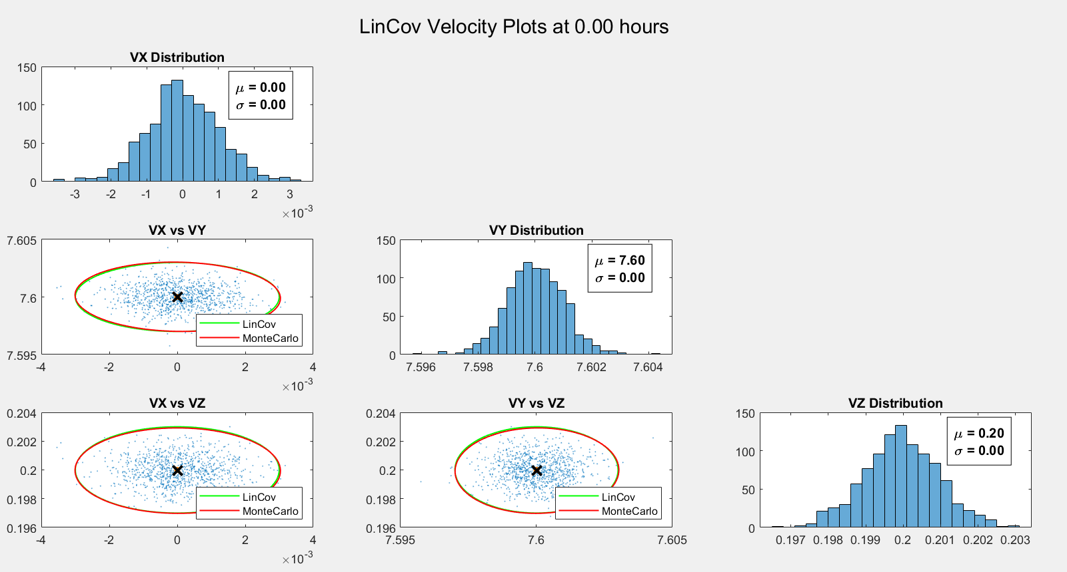

As expected the LinCov Covariance and distribution covariance line up well to start.

Time 6-hour plots

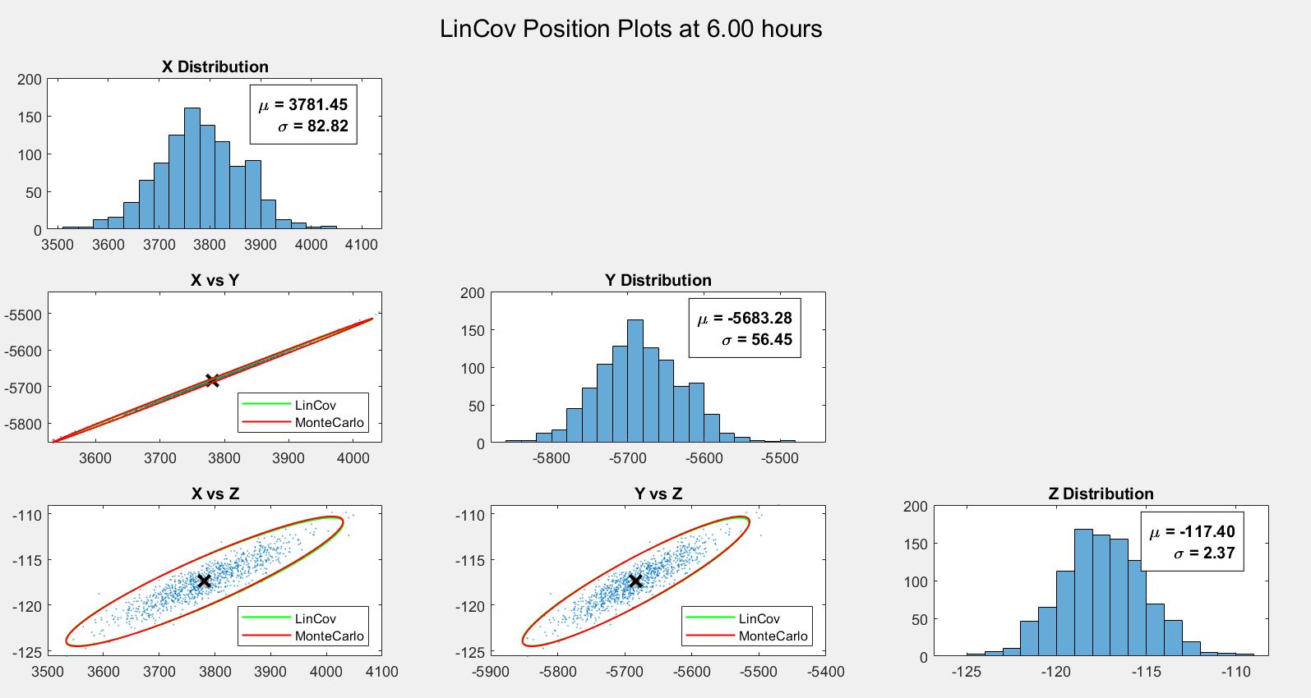

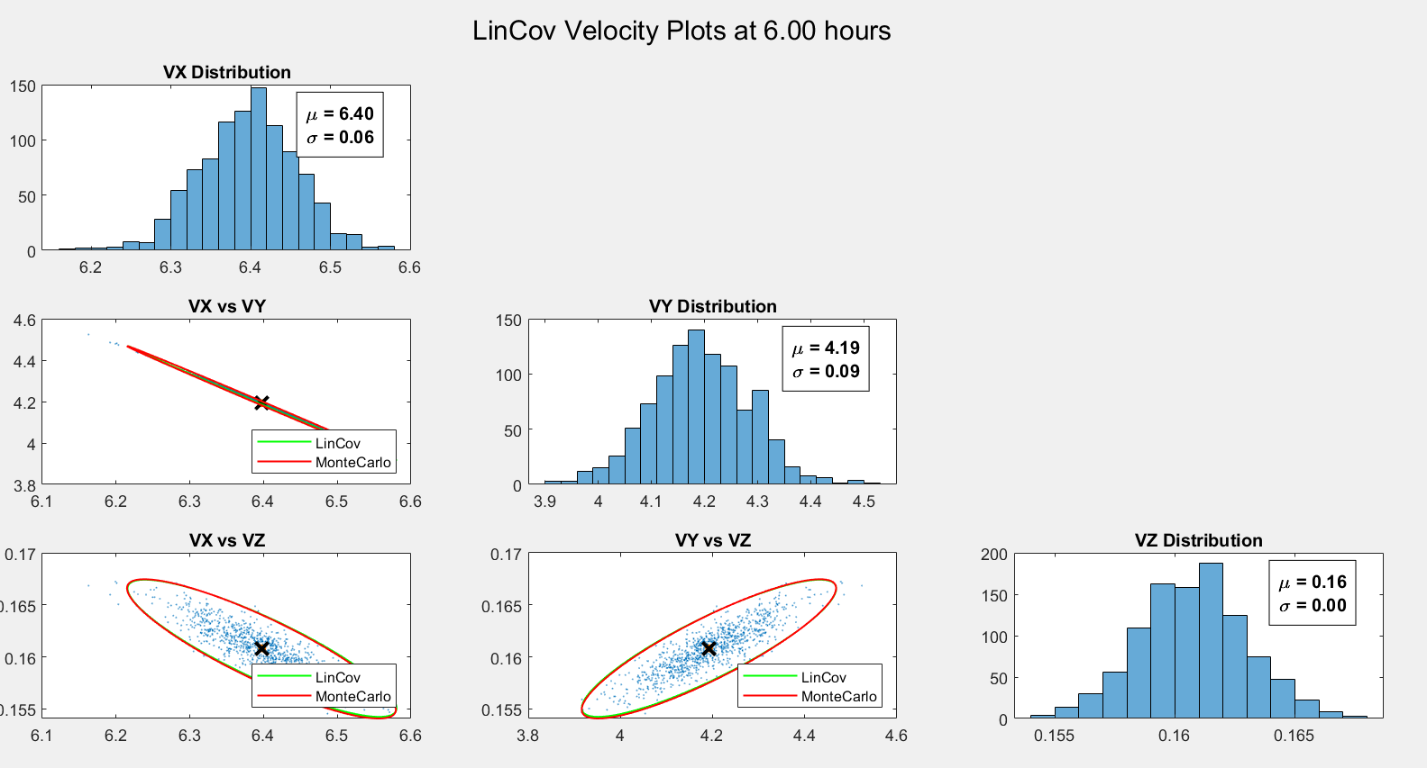

Things still line up fairly well at the 6 hour mark between both covariances.

Time 12-hour plots

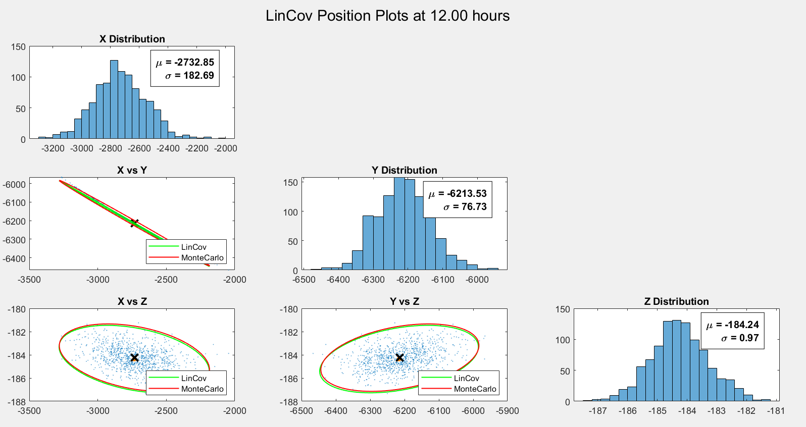

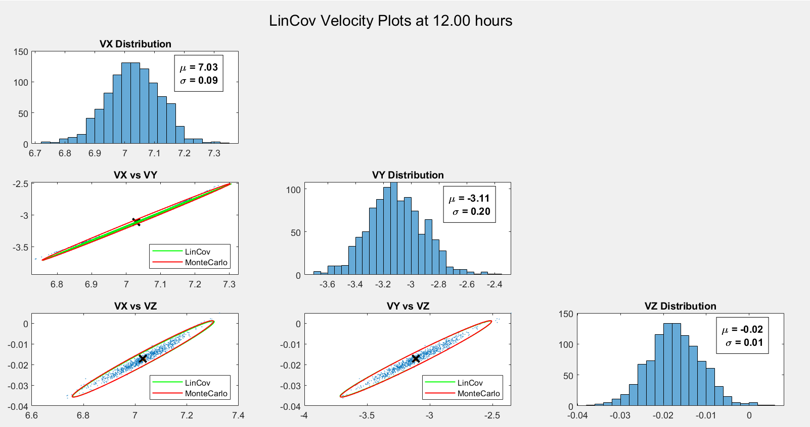

After 12 hours the covariances start to really differ in the X direction.

Time 18-hour plots

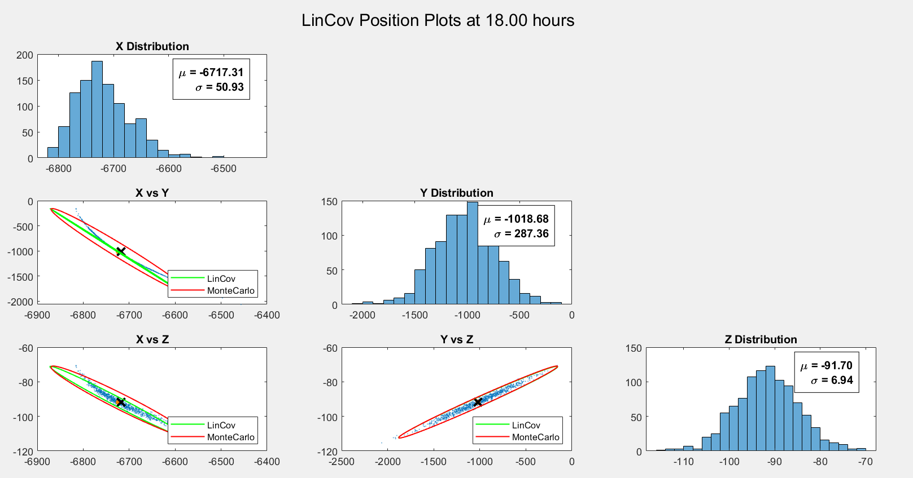

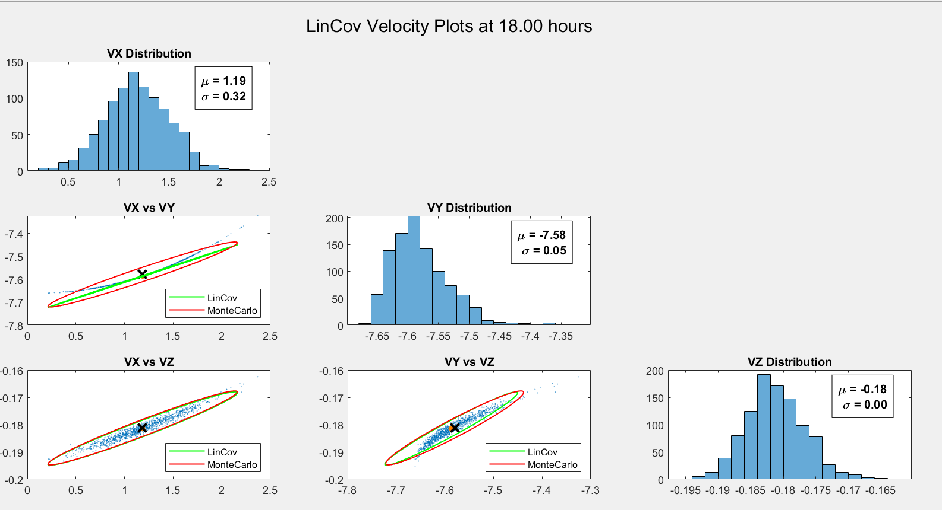

After 18 hours, the differences in the covariances become very apparent when looking at the X and Y directions. The linearized covariance starts doing a poor job of capturing the second moment of the distribution.

Time 24-hour plots

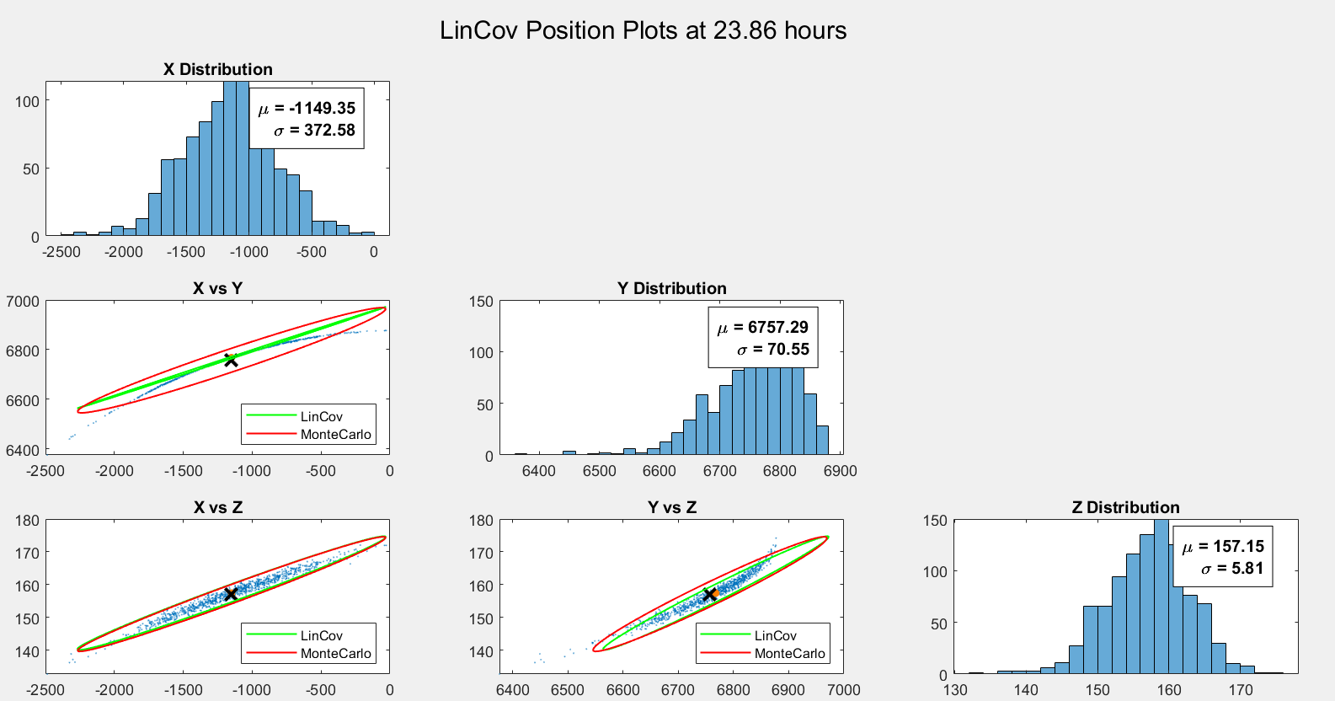

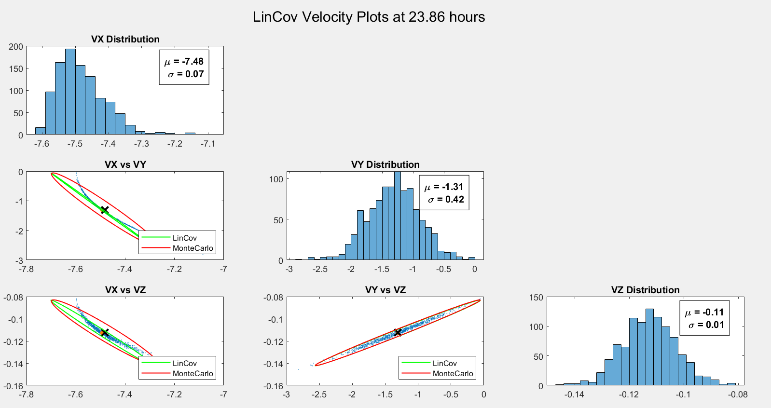

Finally after 24 hours, the Monte Carlo distribution mean is no longer within the Linearized covariance bounds. This shows the limitations of using an STM (which is only a first order approximation) for propagation in time with nonlinear dynamics. Eventually it will only be applicable so close to the nominal trajectory that any perturbations will cause the estimate to be outside of the uncertainty bounds.

c. Using the Mahalanobis distance the percentage of points within the 3-sigma Linearized covariance for the position X vs Y (because this one is the most exciting) was found to only be 45.5% of the points. Meaning that most of the distribution points laid outside of the uncertainty bounds.

1. **UKF Covariance Propagation**

The same analysis was conducted but now the unscented transform is utilized. The second moment is able to be captured much better with this method as it does not rely on an STM at all and functions more like a Monte Carlo simulation.

Time 0-hour plots

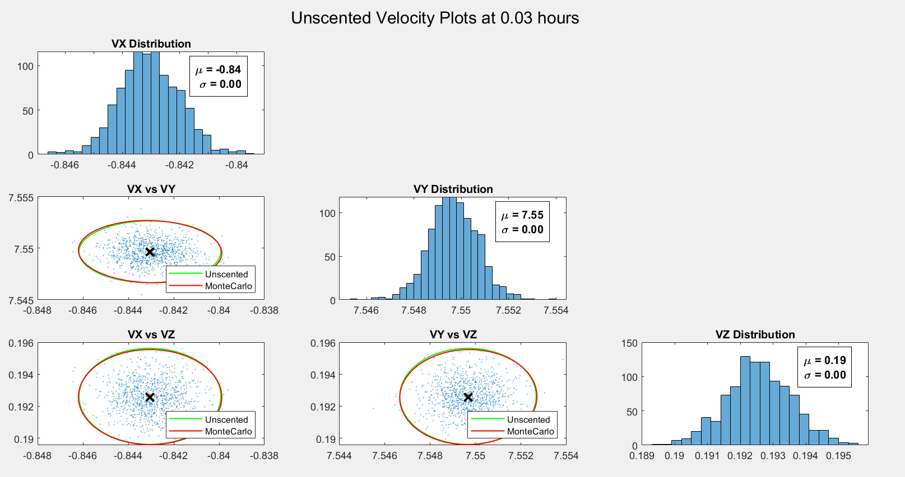

Much of the same as we saw previously at the start as the distribution has yet to be propagated.

Time 6-hour plots

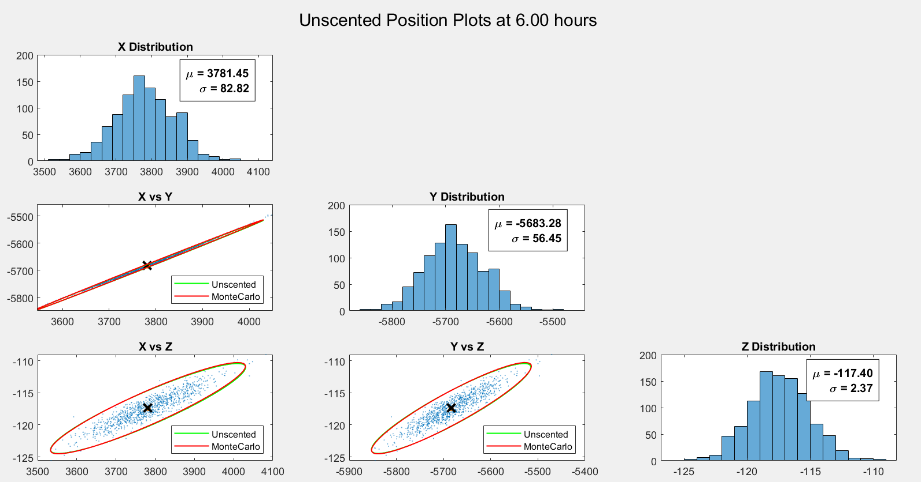

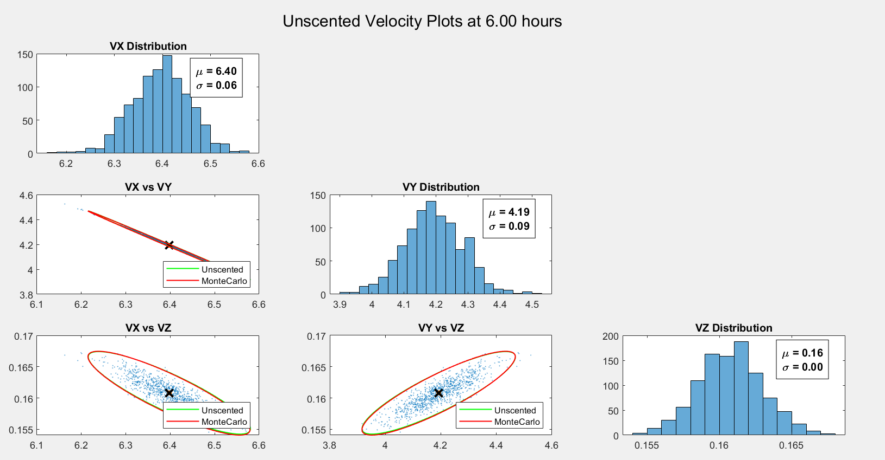

Things still match well.

Time 12-hour plots

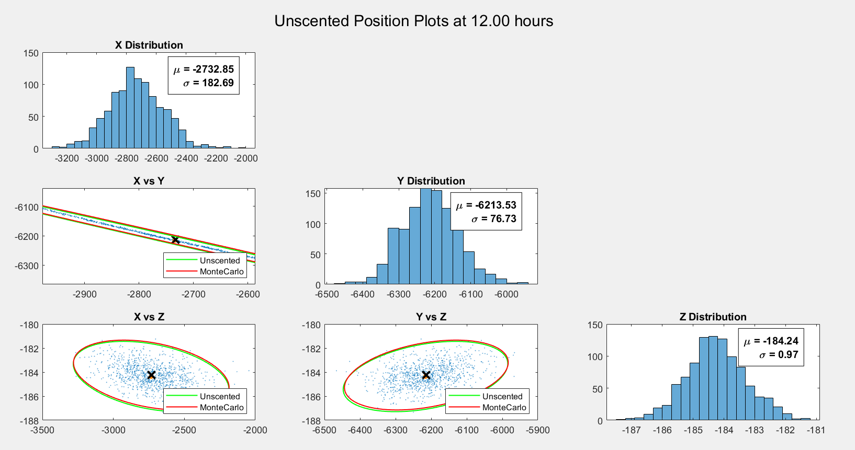

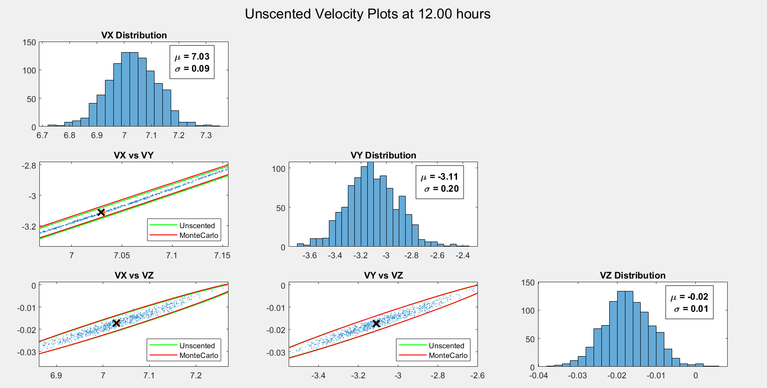

Even after 12 hours the Unscented transform is able to match the distribution covariance well.

Time 18-hour plots

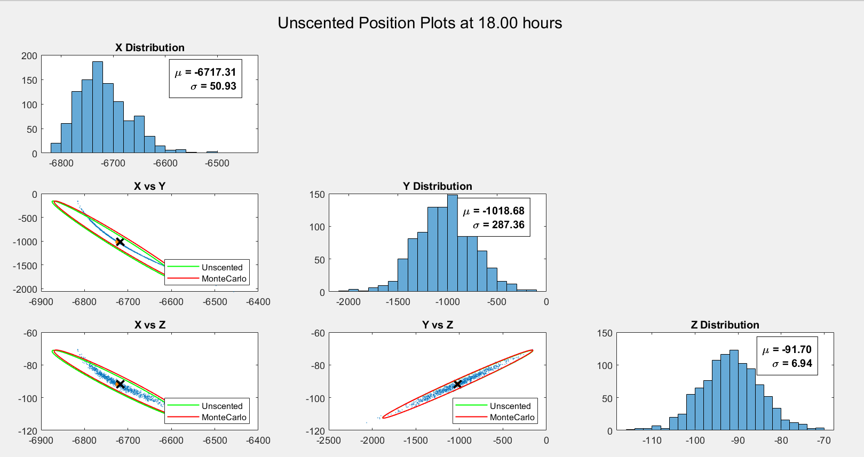

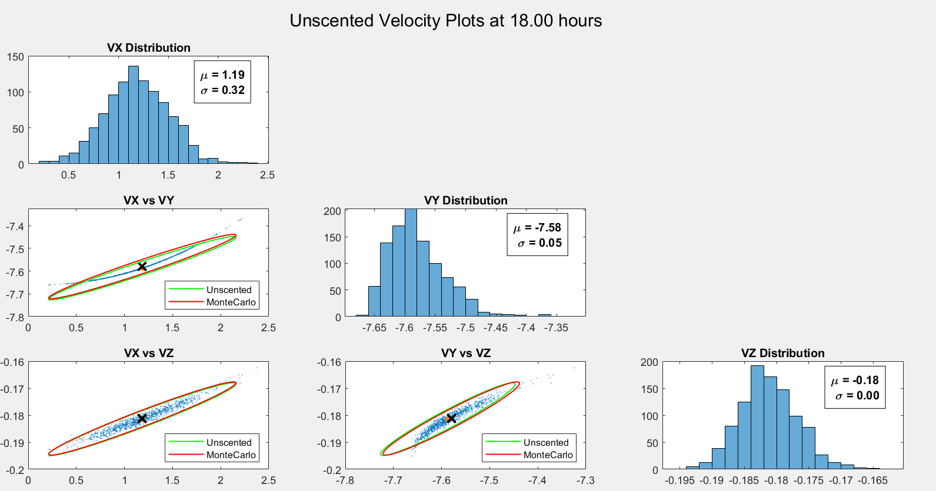

Even with a prominent banana shape, the Unscented covariance is still matching the distribution covariance very closely!

Time 24-hour plots

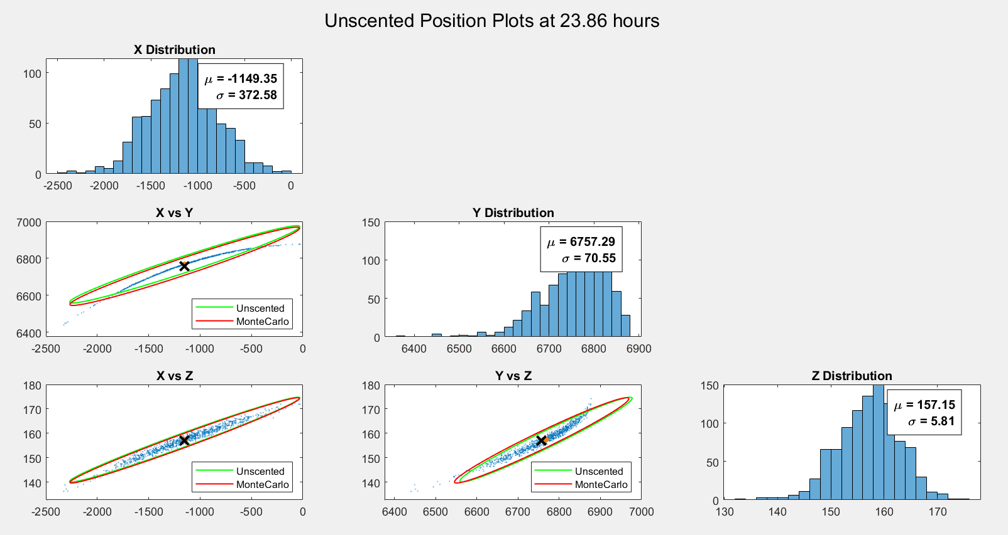

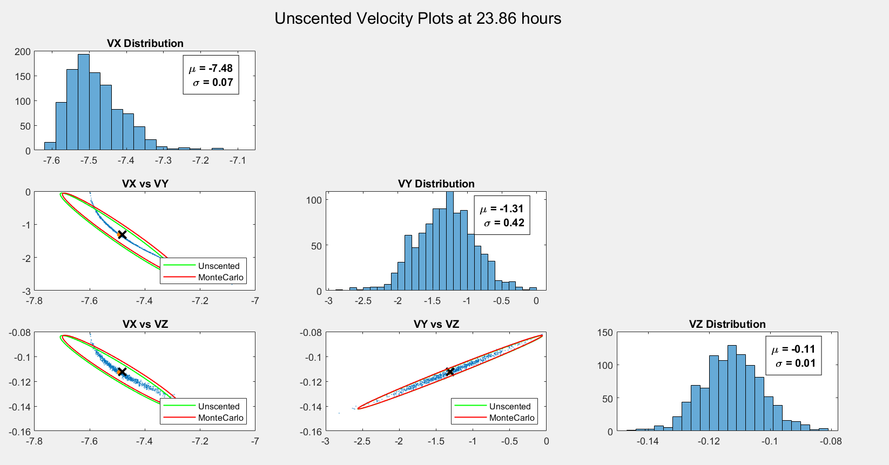

c. Utilizing the Mahalanobis distance, the number of points within the 3-sigma Unscented covariance bounds for X vs Y position was found to be 93.9%! A drastic improvement over the linearized covariance approach! This gets at the heart of the differences in both of the filtering techniques. The Unscented transform does not rely on a first order STM like the Linearized does and can therefore maintain the second moment of the distribution much better. However, even the Unscented covariance will soon no longer match the distribution covariance given long enough time.

**4. Gaussian Sums Covariance Propagation**

I used a Gaussian sums approach to approximate the variance of the distribution in this section. I honestly didn’t have too much rhyme or reason for the distributions that I picked. I was mostly just playing around with what possibilities there were and trying to see if I could get close to the banana shape.

Time 0-hour plots

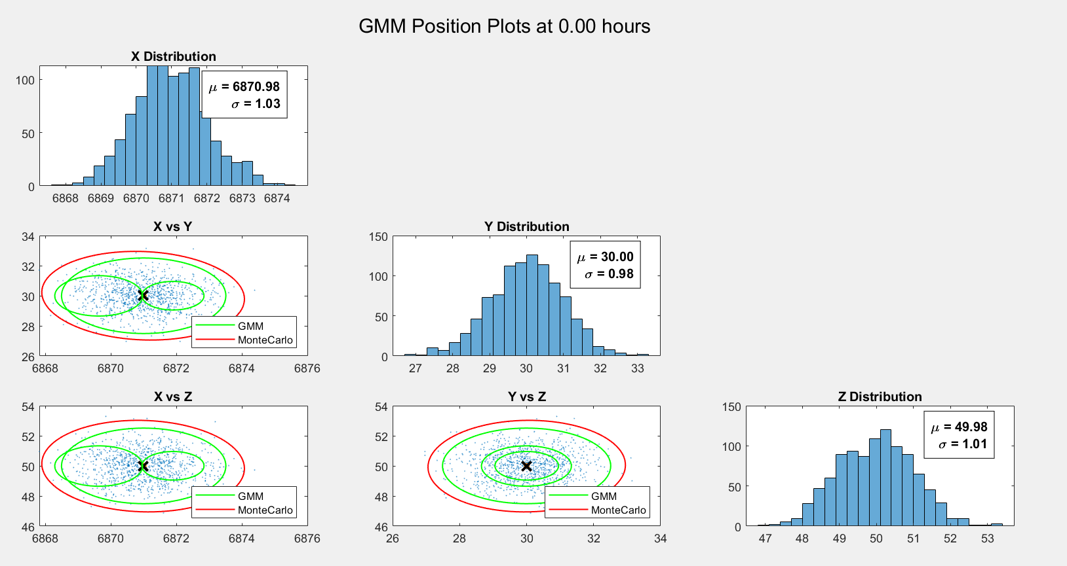

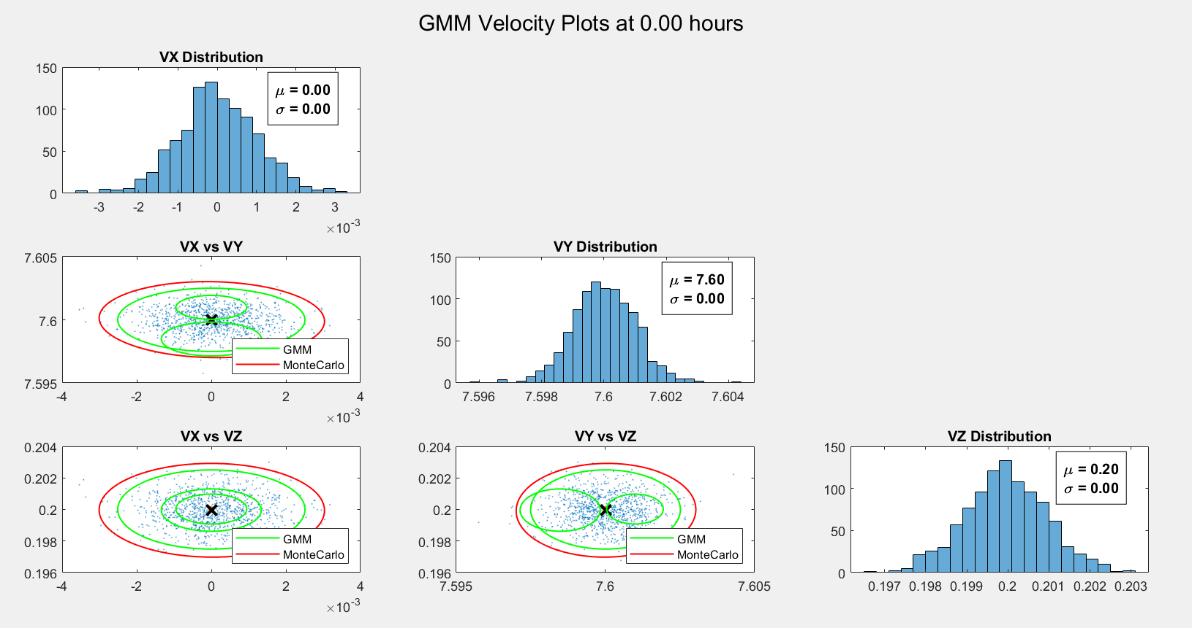

I picked distributions with means fairly close to the nominal trajectory with 3 different covariances.

Time 6-hour plots

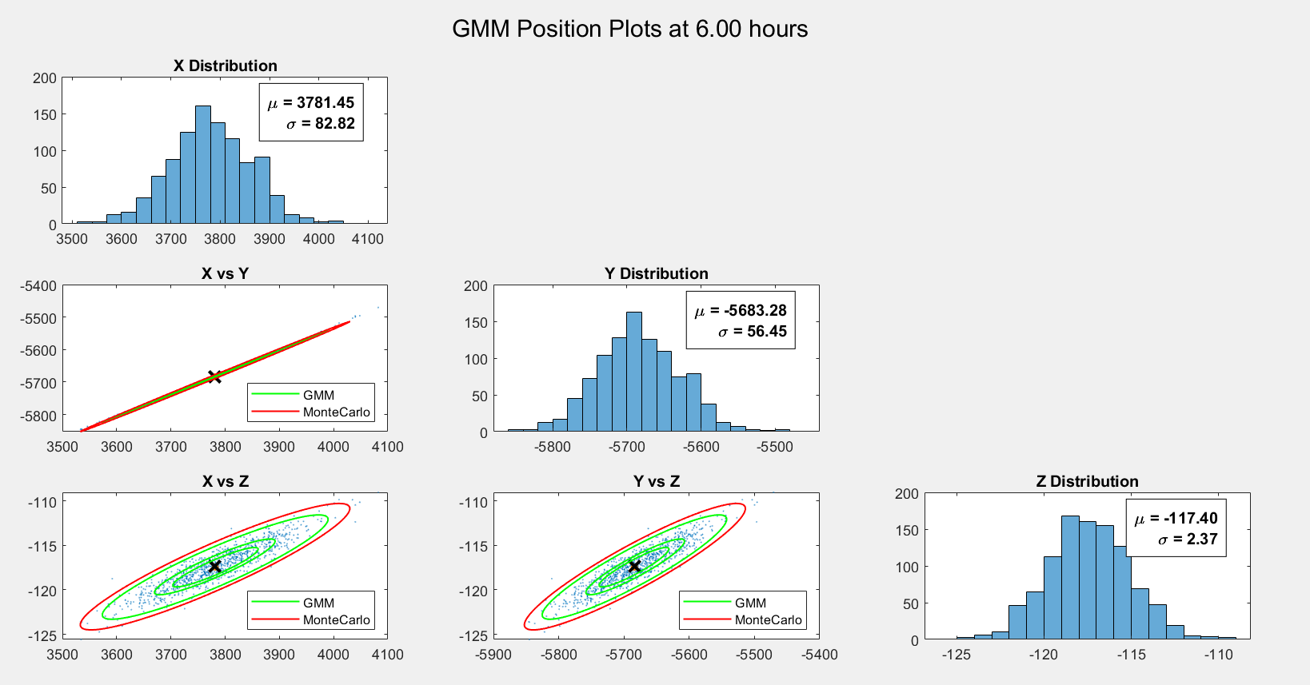

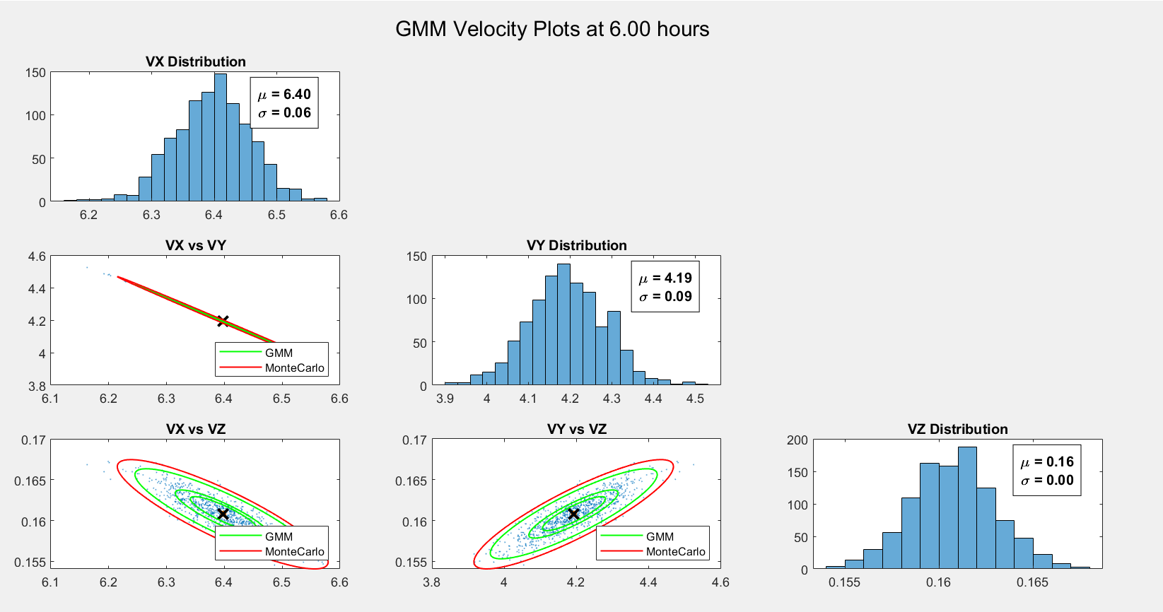

Looks like the distributions were close to the nominal to start with and have gotten even closer now and even concentric now. I guess this might not end up being very informative.

Time 12-hour plots

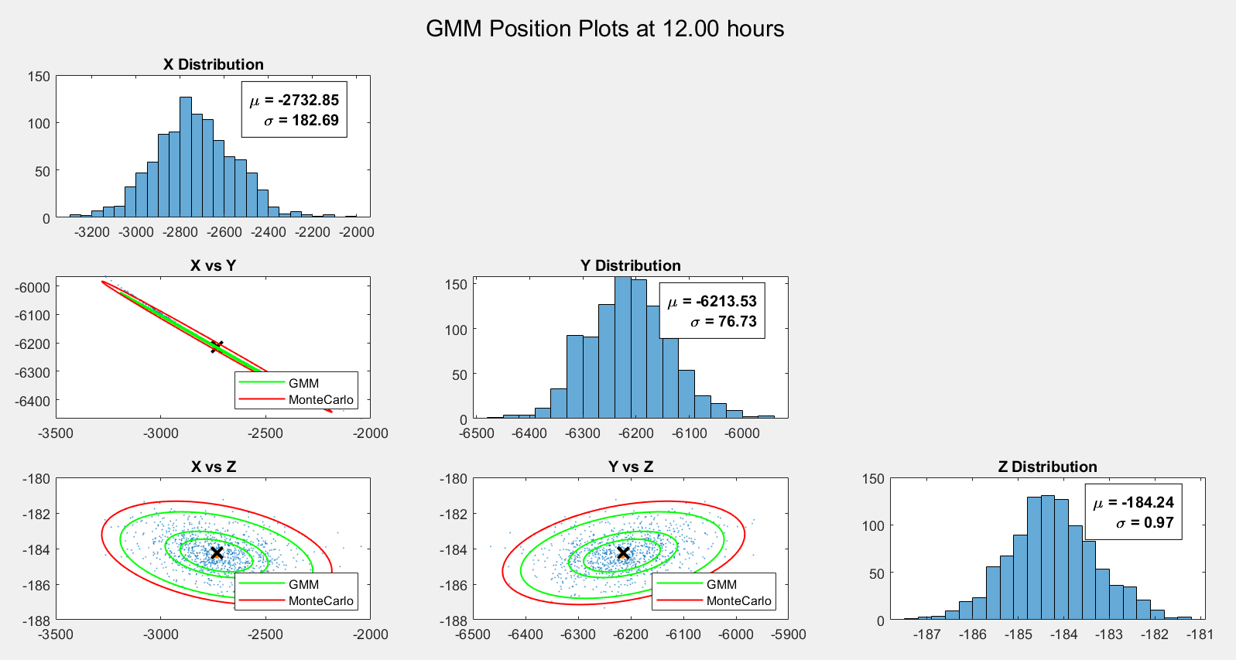

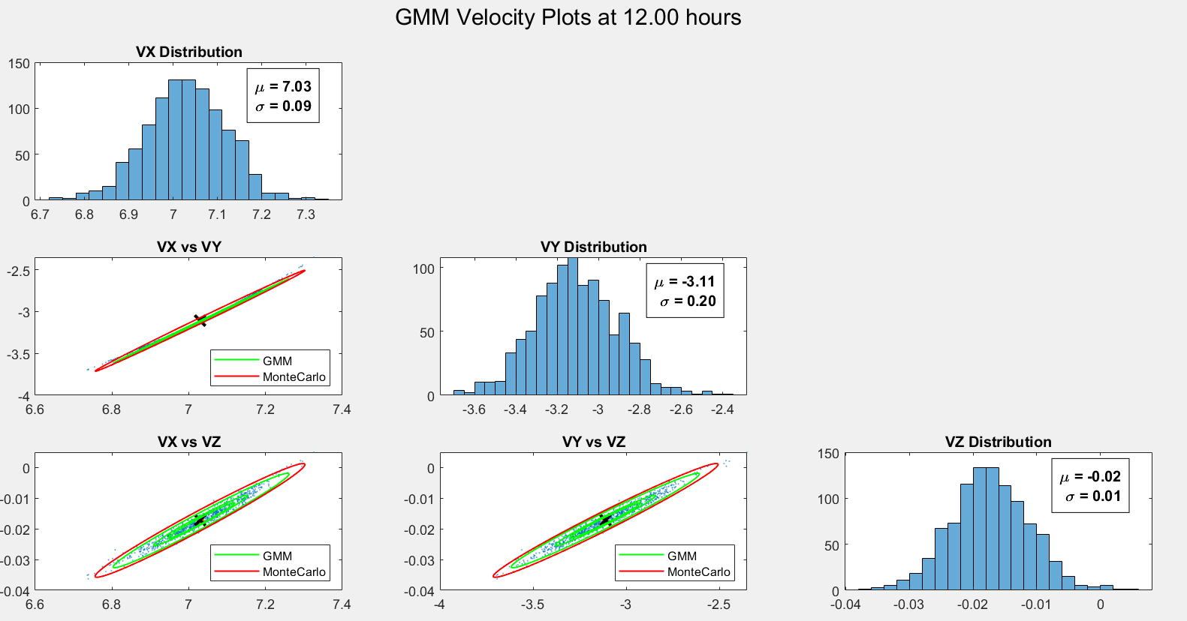

Time 18-hour plots

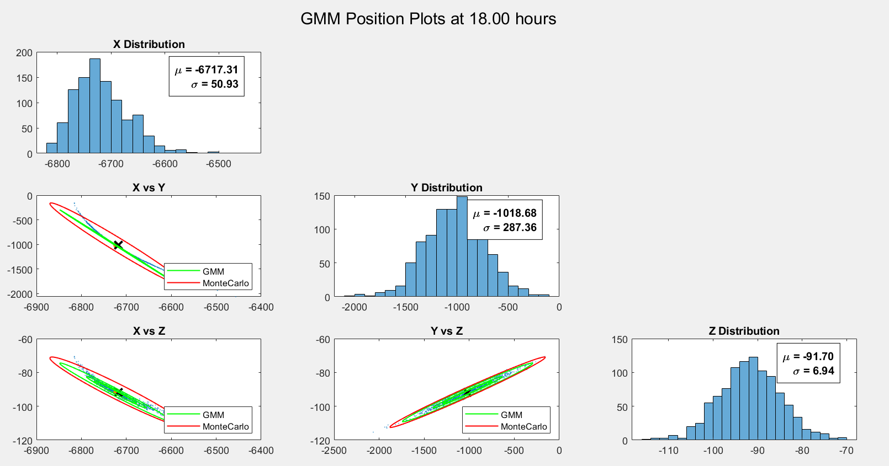

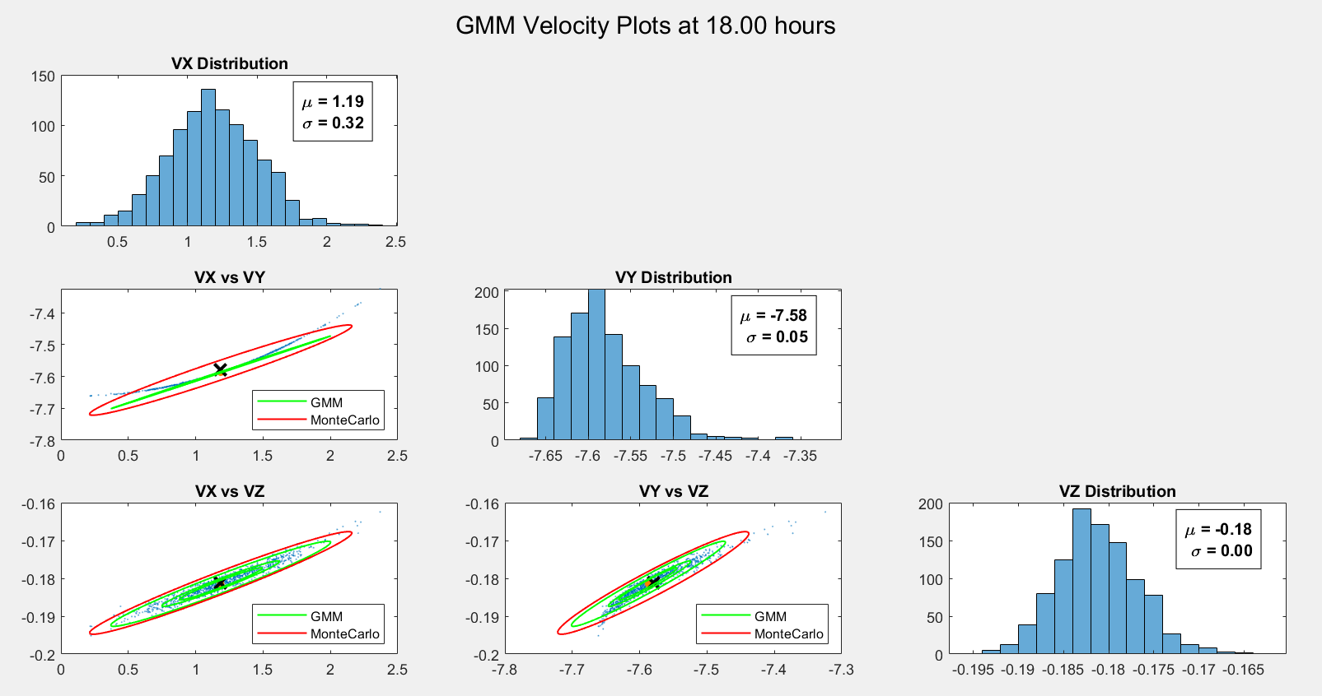

With the banana shape becoming more apparent I would hope that the Gaussian mixtures would try to help approximate it more, however they seem to have just stayed near the nominal trajectory and not provide much more useful information about the variance of the distribution.

Time 24-hour plots

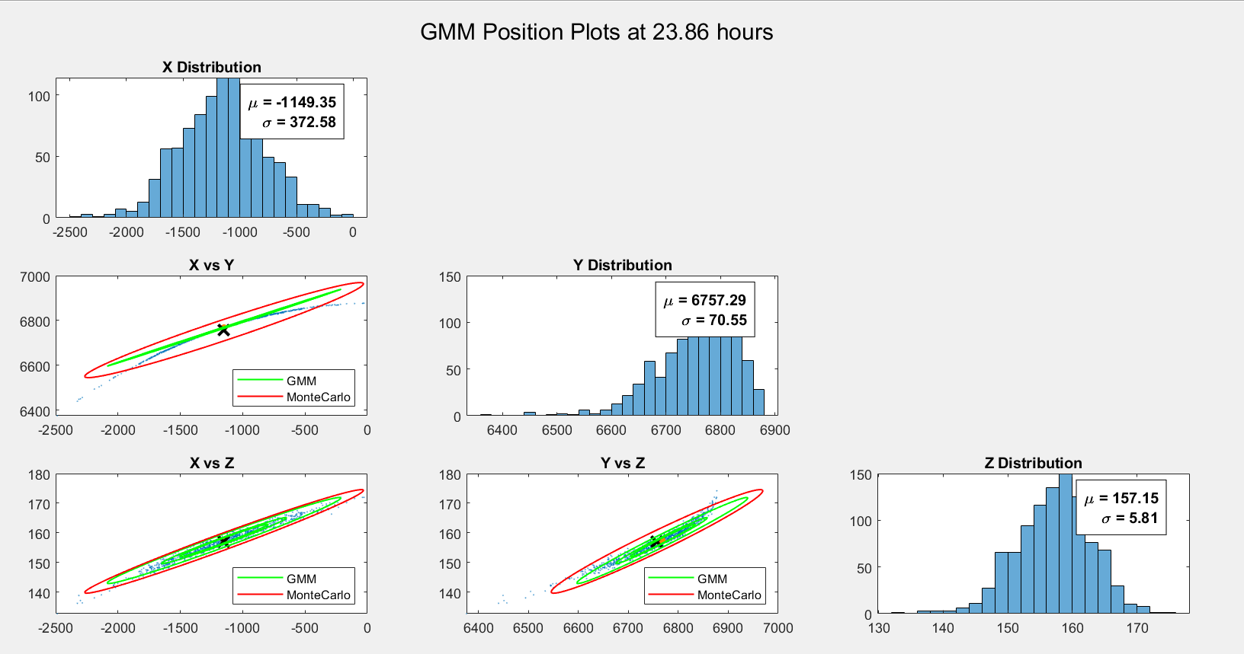

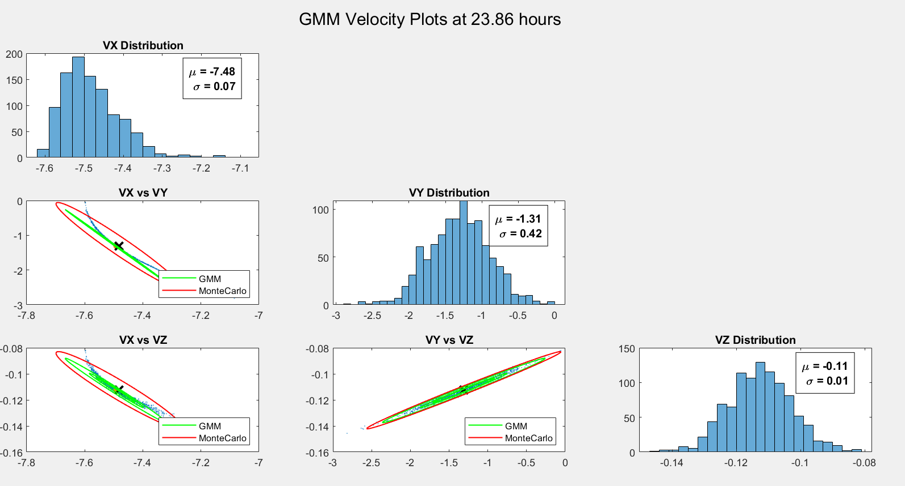

Well, it seems that these gaussians didn’t really provide much more insight into the nonlinear effects that the distribution experiences as time goes on. Perhaps picking gaussians that were further from the mean would give more insight information.

c. 3 Gaussians were used for this and the results were very similar to the LinCov with 46% of the points within the 3sigma covariance.

1. **Comparison**

It was clear that the Unscented transform did a very good job with maintaining the variance of the distribution through the nonlinear propagation effects. This was expected as the UKF was the most complicated to implement and had the most amount of computing power required. The LinCov model works for propagations that don’t go too far into the future and if the true state doesn’t vary very far from the nominal trajectory. As was seen at the very end for the LinCov, the distribution mean was outside of the uncertainty bounds however it was fairly easy to implement and quick to run. The GMM was difficult because I wasn’t able to get a very good result because there are so many degrees of freedom to choose from when setting that up.